**<Group05>**

**<Re:Book>**

**Use-Case Specification**

**Version <2.0>**

**Revision History**

| **Date** | **Version** | **Description** | **Author** |
| --- | --- | --- | --- |
| <13/11/2021> | <1.0> | <details> | <Dinh Dinh, Khoi Quach, Ngan Nguyen, Thu Nguyen, My Le> |
| <27/11/2021> | <2.0> | <modify Use case Model> | <Dinh Dinh, Khoi Quach, Ngan Nguyen, Thu Nguyen, My Le> |
|  |  |  |  |
|  |  |  |  |

**Table of Contents**

**Use-case Model (usecase.png)** **4**

**Use-case Specifications** **4**

Use-case: Log in 4

Use-case: Register 5

Use-case: Change password 5

Use-case: Forgot password 6

Use-case: Save books to favorite list 6

Use-case: Create collection 7

Use-case: Generate new book list everyday 7

Use-case: Receive notifications through email 8

Use-case: Respond to recommend list 9

Use-case: Filter books 9

Use-case: Review books 9

Use-case: Report comments 10

Use-case: View activities diary 10

Use-case: Plant virtual trees 11

Use-case: Collect trees 11

Use-case: Release trees according to seasons or special events 12

Use-case: Create books 12

Use-case: Edit book's information 13

Use-case: See the interaction data of reviewers 13

Use-case: Update profile information 14

Use-case: Change profile’s image 14

Use-case: View Book 15

# **Use-case Model (usecase.png)**

<https://drive.google.com/file/d/10CaMWRM_T98fZHymYlrWNjY1z3_D5xou/view?usp=sharing>

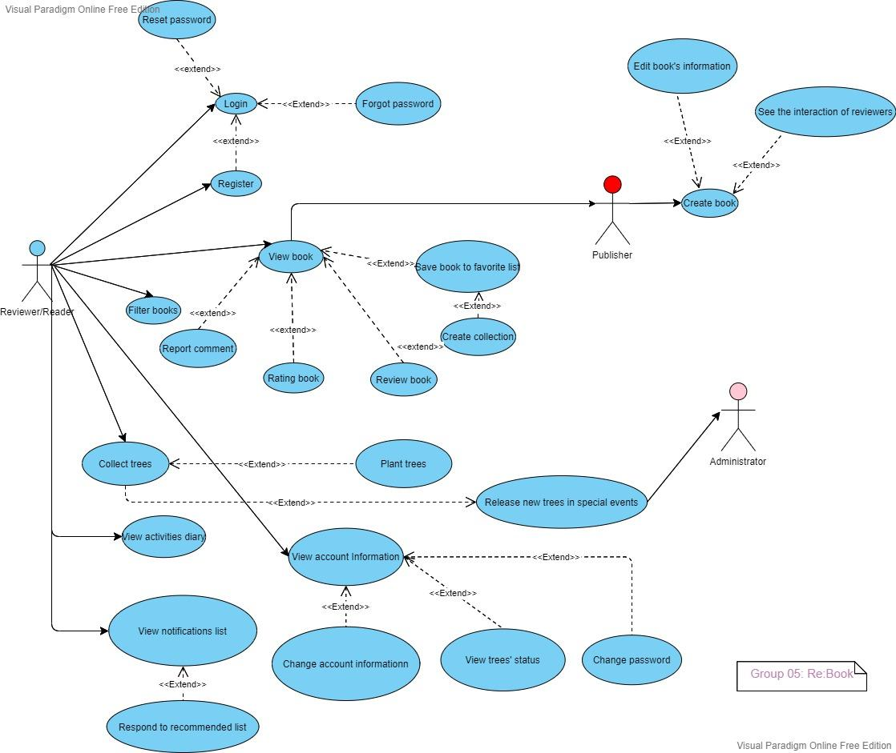

# **Use-case Specifications**

## Use-case: Log in

| Use case Name | Log in |
| --- | --- |
| Brief description | Have the ability to log in by social accounts like: Facebook, Google or by existing account name and password. |
| Actors | Reviewer (Reader), Publisher |
| Basic Flow | 1. Open website, System displays the Login page. 2. Typing the username and password. 3. Click the button “Log in” to change to Homepage “Re:Book”. |
| Alternative Flows | **Alternative flow 1: Facebook**   1. From the step #1 of the basic flow, click on “Sign in with Facebook” 2. Connect to your Facebook account and verify if it is you. 3. Change to Homepage “Re:Book”   **Alternative flow 2: Google**   1. From the step #1 of the basic flow, click on “Sign in with Google” 2. Connect to your Facebook account and verify if it is you. 3. Change to Homepage “Re:Book” |
| Pre-conditions | Users go to the website of Re:Book. |
| Post-conditions | The user successfully access to the homepage of Re:Book |

## Use-case: Register

| Use case Name | Register |
| --- | --- |
| Brief description | Register for the first time login by username and password. |
| Actors | Reviewer (Reader, Publisher) |
| Basic Flow | 1. Open website, System displays the Login page. 2. Under the space for typing username and password, there is a button register. 3. Click to this button, and you are transferred to the Register page. 4. Input valid email, username and password. 5. After that, the website changes to the screen “Verify the email”. Now, you have to move to your email and click to “Verify the email of Re:Book” 6. Return to the website to move to Homepage “Re:Book” |
| Alternative Flows | **Alternative flow 1: Facebook**   1. From the step #1 of the basic flow, click on “Sign up with Facebook” 2. Connect to your Facebook account and verify if it is you. 3. Change to Homepage “Re:Book”   **Alternative flow 2: Google**   1. From the step #1 of the basic flow, click on “Sign up with Google” 2. Connect to your Facebook account and verify if it is you. 3. Change to Homepage “Re:Book”   **Alternative flow 3: When input the existing email**   1. In step #4, the website informs that “This email has already existed. Do you want to log in”. 2. If you choose Yes, you will change to the “LogIn” screen. 3. If you choose No, you will stay at this screen. |
| Pre-conditions | User goes to the website Re:Book |
| Post-conditions | The user successfully register the account and move to the homepage Re:Book |

## Use-case: Change password

| Use case Name | Change password |
| --- | --- |
| Brief description | For security, you can change your password. |
| Actors | Reviewer (Reader, Publisher) |
| Basic Flow | 1. After the user login 2. At the homepage, in the Menu area, choose your profile. 3. Features of your profile appears, choose “Account” to change to Account screen 4. Click on “Change password”. 5. Input your old password and click Ok. If it’s right, move to step 6. If wrong, you will be asked to do it again. 6. Input your new password, and input again to verify them. 7. Click Ok and move to the initial Account screen. |
| Alternative Flows | **Alternative flow 1: User want to cancel the action**   1. From #5, Click Cancel and move to the initial Account screen.     **Alternative flow 2: Your new password is the same as your old password**   1. From #6, the System informs “Your new password is the same as your old password. Please input a new one.” 2. Click on OK if you want to continue the action or Cancel to move to the initial Account screen. |
| Pre-conditions | User goes to homepage of Re:Book and accesses to “Profile” |
| Post-conditions | The user successfully changes the password to the new one. |

## Use-case: Forgot password

| Use case Name | Forgot password |
| --- | --- |
| Brief description | You reset your password and security info. |
| Actors | Reviewer (Reader, Publisher) |
| Basic Flow | 1. At the user login page 2. Click on “Forgot password”. 3. Input your email and click Ok. If it’s in DB, the system will send the notification to your email. |
| Alternative Flows |  |
| Pre-conditions |  |
| Post-conditions | The user successfully gets the password. |

## **Use-case: Save books to favorite list**

| Use case Name | Save books to favorite list |
| --- | --- |
| Brief description | Choose some books to add in the user’s favorite list for later review |
| Actors | Reviewer (Reader) |
| Basic Flow | 1. At the page of the book’s description 2. Users click on the “Save to Favorite” button 3. System will navigate to the user’s Favorite List page 4. Users are asked to add the book in a folder 5. Users click on the folder, then clicks the “Add” button 6. A dialog will comes up to announce the success of book’s addition |
| Alternative Flows | **Alternative flow 1: User do not want to add the book anymore**  4. At the Favorite List page  5. Instead of choosing a folder to add in, users can click the “Cancel” button adjacent to the “Add” one to stop.    **Alternative flow 2: Users want to add the book in a new folder**   1. At the Favorite List page 2. Users click on the icon “Create new folder” 3. Users name the folder and then press Enter 4. Users continue as step 5 in Basic Flow |
| Pre-conditions | User clicks to view the book’s description |
| Post-conditions | The user successfully adds the book to his/her favorite list. |

## 

## Use-case: Create collection

| Use case Name | Create collection |
| --- | --- |
| Brief description | Create a folder, where users can put their book in their own manner for later read or review |
| Actors | Reviewer (Reader) |
| Basic Flow | 1. At the Favorite List page 2. Users click on the icon “Create new folder” 3. Users name the folder and then press Enter |
| Alternative Flows | **Alternative flow 1: User want to create a sub-folder**   1. At the Favorite List page 2. Users choose the folder to create a sub-folder inside 3. Continue with the step 2 in the Basic Flow     **Alternative flow 2: Users can create a folder when adding a book to Favorite List**   1. Follow the Alternative flow 2 in the use-case Save books to favorite list |
| Pre-conditions | User goes to Favorite List page |
| Post-conditions | A folder is successfully added in the Favorite List. |

## 

## Use-case: Generate new book list everyday

| Use case Name | Generate new book list everyday |
| --- | --- |
| Brief description | Random from favorite categories or authors, create a new recommended list for a certain user based on their chosen category and their books in the Favorite List. |
| Actors | System |
| Basic Flow | 1. The system collect favorite categories or author in reader list 2. It random new book list 3. Show to the reader |
| Alternative Flows | **Alternative flow 1: Use case category**   1. After show the list to the reader 2. The reader select category button to order book by category   **Alternative flow 2:**   1. Administrator takes the user’s chosen category 2. Administrator takes extra categories based on the user’s books in their Favorite List 3. Administrator create a list of random books (20) based on the categories taken from the user 4. The list will be updated daily and showed in the Homepage |
| Pre-conditions | Add favorite books to list |
| Post-conditions | The system successfully recommend new book list everyday |

## 

## Use-case: Receive notifications through email

| Use case Name | Receive notifications through email |
| --- | --- |
| Brief description | Notifications about recommended books everyday through email |
| Actors | Reader |
| Basic Flow | 1. User go to “Setting” button 2. Turn on receiving notification through email |
| Alternative Flows | **Alternative flow 1: Not enter email address**   1. Reader click on “Enter email” button 2. Show the box for enter email 3. Reader click on “Enter” button 4. Verify email through link in email   **Alternative flow 2: Change email address**   1. Reader click on “Change email” button 2. Show the box for enter email 3. Enter email again to confirm 4. Reader click on “Enter” button 5. Verify email through link in email |
| Pre-conditions | After the user login |
| Post-conditions | The reader successfully receives notifications through email |

## 

## Use-case: Respond to recommend list

| Use case Name | Respond to recommend list |
| --- | --- |
| Brief description | Like/Dislike for better recommendation |
| Actors | Reader |
| Basic Flow | 1. “Like/Dislike” button at the bottom of recommend list 2. Reader choose one button to respond 3. Show the box has “Thanks for your response” text |
| Alternative Flows | Like basic flow |
| Pre-conditions | Add books to favorite list |
| Post-conditions | The reader successfully reaction to the recommendation |

## 

## Use-case: Filter books

| Use case Name | Filter books |
| --- | --- |
| Brief description | Allow user to apply filter for fast searching books |
| Actors | Reader |
| Basic Flow | 1. User can see the filter on the right hand side of the website 2. Tick categories/date/author box and press “apply” button and see the result |
| Alternative Flows | None |
| Pre-conditions | None |
| Post-conditions | The reader successfully see the results after apply the filter |

## 

## Use-case: Review books

| Use case Name | Review books |
| --- | --- |
| Brief description | Write review for a book in the comment section |
| Actors | Reader |
| Basic Flow | 1. Login if you already have an account. If not, you must register 2. Click a book to view the details 3. In the comment section, you can write a review for a book. 4. You can also attach image in your review |
| Alternative Flows | None |
| Pre-conditions | * After user login * The book exists |
| Post-conditions | Your comment is displayed |

## 

## Use-case: Report comments

| Use case Name | Report comments |
| --- | --- |
| Brief description | Report a review if it violates the community guidelines. |
| Actors | Reader |
| Basic Flow | 1. Login if you already have an account. If not, you must register 2. Click a book to view the details 3. In the comment sections, you may see some reviews. If you see any of them violates the community guidelines, you can click the report button 4. If the number of report reaches the limitation, the server will send notification to administrator 5. Administrator decides to delete or keep that reviews |
| Alternative Flows | None |
| Pre-conditions | * After user login * The book exists * There are at least one review in the comment section which violates the community guidelines |
| Post-conditions | If your report request is accepted, you will never see that comments anymore |

## Use-case: View activities diary

| Use case Name | View activities diary |
| --- | --- |
| Brief description | Allow users to view all of their activities history |
| Actors | Reader |
| Basic Flow | 1. Login if you already have an account. If not, register 2. Move to your profile pages and click the activities diary |
| Alternative Flows | None |
| Pre-conditions | * After user login * The user have already interact with the website |
| Post-conditions | You can see all the activities you have done so far, including comments, reaction, ratings,... |

## 

## Use-case: Plant virtual trees

| Use case Name | Plant virtual trees |
| --- | --- |
| Brief description | Users can plant their trees based on the number of characters in their comments |
| Actors | Reader, Server |
| Basic Flow | 1. Login if you already have an account. If not, register 2. Click a book to view the details 3. Write the review of book in the comment section 4. The server will count the number of character and plant user’s trees |
| Alternative Flows | None |
| Pre-conditions | * After user login * The user have already review for a book |
| Post-conditions | The trees will grow depending on the number of characters in user’s reviews |

## 

## Use-case: Collect trees

| Use case Name | Collect trees |
| --- | --- |
| Brief description | User can exchange the trees they grew for the new favorite trees |
| Actors | Reader |
| Basic Flow | 1. Login if you already have an account. If not, register 2. The user click the store button in navigation bars to view the trees 3. Each tree in the store may need a number of trees to exchange. If the user earned enough trees, they can exchange for their favorite ones |
| Alternative Flows | None |
| Pre-conditions | * After user login * The user have enough trees to exchange |
| Post-conditions | The user lost a number of their old trees and have new trees |

## 

## Use-case: Release trees according to seasons or special events

| Use case Name | Release trees according to seasons or special events |
| --- | --- |
| Brief description | The administrator create a new trees in the store for special events |
| Actors | Administrator |
| Basic Flow | 1. Login in the website as administrator 2. Move to the store by clicking store button in navigation bar at homepage 3. Click the button “add a new tree” and input the information of the tree, which are image, number of trees needed to exchange,... |
| Alternative Flows | None |
| Pre-conditions | * After administrator login |
| Post-conditions | A new tree appears in the store and is ready for the user to pick. |

## 

## **Use-case: Create books**

| Use case Name | Create books |
| --- | --- |
| Brief description | When you cannot find a book on website, you can create it for everyone to review |
| Actors | Publisher |
| Basic Flow | 1. After the user login 2. At the menu, the publisher clicks on the “New Record” button 3. System displays the form to create a new book 4. Publisher fill in the create form for full details 5. System adds a new book to the bookshelf 6. System displays the information of new book to the user |
| Alternative Flows | **Alternative flow 1: Publisher wants to check if the book exists before adding new one**   1. After the publisher login 2. At the menu, the publisher enters the book’s name on the ‘Search’ field 3. Publisher clicks on ‘Search’ button to start searching a book 4. System displays the book found 5. If system cannot find the book, the system will display a form for publisher to publish new book 6. Publisher fills in the create form for full details 7. System adds a new book to the bookshelf 8. System displays the information of new book to the user |
| Pre-conditions | After the user login |
| Post-conditions | The publisher successfully adds a new book to the bookshelf |

## Use-case: Edit book's information

| Use case Name | Edit book's information |
| --- | --- |
| Brief description | Change the information of your published book |
| Actors | Publisher |
| Basic Flow | 1. After the user login 2. At the menu, the publisher clicks on the “Account” button 3. The publisher continue to select the “My record” button 4. System displays the books that publisher published 5. The publisher clicks on the “Edit” button at the right corner of the book 6. System displays a form for publisher to edit book 7. Publisher fills in the edit form for full details 8. Publisher fills in the edit form for full details 9. Publisher clicks on “Submit changes” button after filling in all the information 10. System edit the book’s information 11. System displays the information of edited book to the user |
| Alternative Flows |  |
| Pre-conditions | After the user publish a book |
| Post-conditions | The publisher successfully edit the published book |

## Use-case: See the interaction data of reviewers

| Use case Name | See the interaction data of reviewers |
| --- | --- |
| Brief description | See the number of comments, reacts and viewing of guests |
| Actors | Publisher |
| Basic Flow | 1. After the user login 2. At the menu, the publisher clicks on the “Account” button 3. The publisher continue to select the “My record” button 4. System displays the books that publisher published 5. The publisher click on a book 6. System shows the book’s information, rating, comments, reacts and viewing of guests |
| Alternative Flows |  |
| Pre-conditions | After the user login |
| Post-conditions | The publisher see the number of comments, reacts and viewing of guests |

## Use-case: Update profile information

## 

| Use case Name | Update profile information |
| --- | --- |
| Brief description | Edit and update the user’s information |
| Actors | Publisher, Reader/ Reviewer |
| Basic Flow | 1. After the user login 2. At the menu, the user clicks on the “Account” button 3. User continues to select the “My profile” button 4. System displays the user’s information 5. User clicks on the “Edit” button at the right corner to update/ edit the information 6. System displays the updated information for user |
| Alternative Flows |  |
| Pre-conditions | After the user login |
| Post-conditions | Successfully edit/ update the user’s information |

## Use-case: Change profile’s image

## 

| Use case Name | Change profile’s image |
| --- | --- |
| Brief description | Upload image from local folder to set avatar |
| Actors | Publisher, Reader/ Reviewer |
| Basic Flow | 1. After the user login 2. At the menu, the user clicks on the “Account” button 3. User continues to select the “My profile” button 4. System displays the user’s information 5. User clicks on the “Change avatar” button and select a picture from local storage 6. System upload the picture to database 7. System show the picture as user’s avatar |
| Alternative Flows |  |
| Pre-conditions | After the user login |
| Post-conditions | The user successfully change avatar |

## Use-case: View Book

## 

| Use case Name | View Book |
| --- | --- |
| Brief description | View the selected book’s information |
| Actors | Publisher, Reader/ Reviewer |
| Basic Flow | 1. After the user login 2. At the menu, the user enters the book’s name on the ‘Search’ field 3. User clicks on ‘Search’ button to start searching a book 4. System displays the book found 5. User clicks on that book to see its information 6. System displays the book’ s information |
| Alternative Flows | **Alternative flow 1: User finds books by Recommended lists**   1. After the publisher login 2. Publisher clicks on “Category” button on menu to see the list of recommended books 3. System displays the list of recommended books 4. User click on a book to see its information 5. System displays the book’ s information   **Alternative flow 2: User finds books by Category**   1. After the publisher login 2. Publisher clicks on “Category” button on menu to see the list of recommended books 3. System displays the list of categories 4. User clicks on a name of category 5. System displays list of books in that category 6. User clicks on a book to see its information |
| Pre-conditions | After the user login |
| Post-conditions | The user successfully see the book’s information |

## 